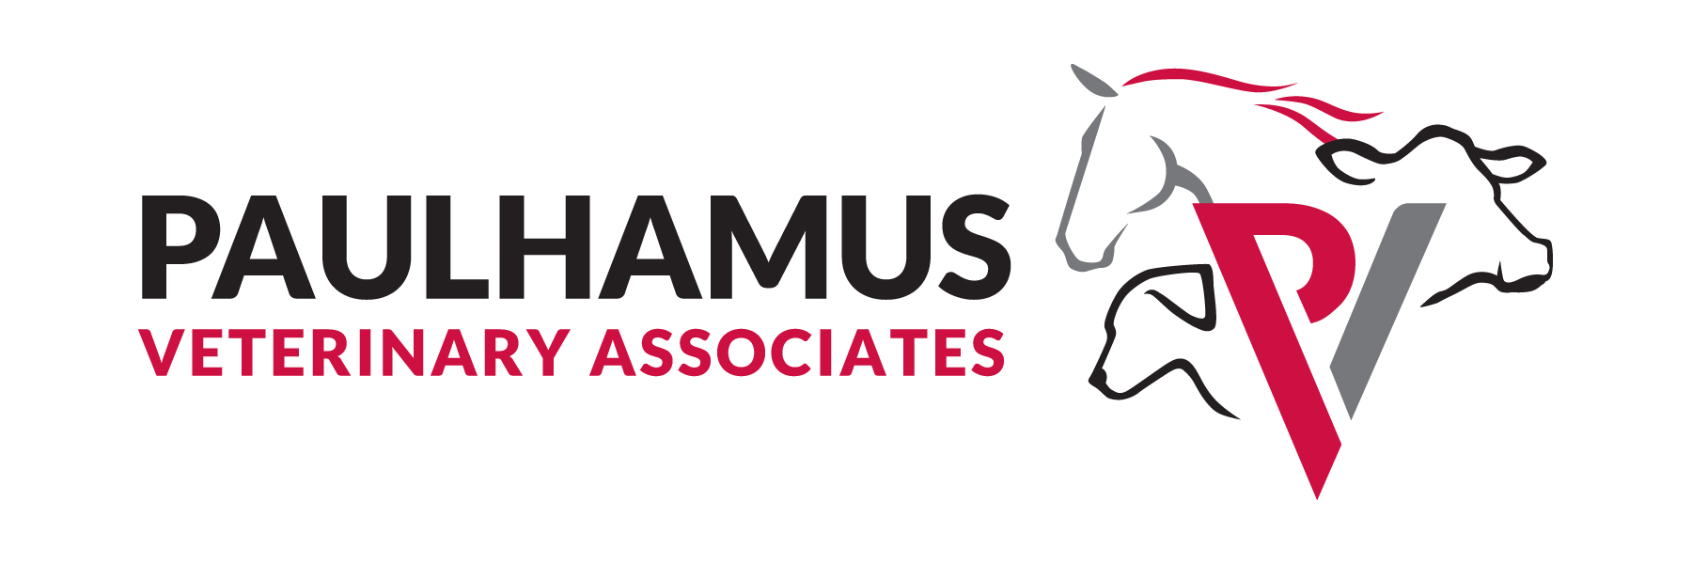
190 Paulhamus Road | Linden, PA 17744
(570)220-6316 | paulhamusveterinary.com

Financial Policy

Thank you for choosing Paulhamus Veterinary Associates. Our primary mission is to deliver the best and most comprehensive veterinary care available for your animals. An important part of this mission is making the cost of optimal care as easy and manageable for our clients as possible by offering several payment options.

Payment Options

Payment is generally due at the time of service. If payment is not rendered at the time of service, you can agree to pay using one of the following options:

 I would like to receive my invoice via  e- mail or  surface mail immediately following my appointment. I will pay via  cash/check or
 credit card. I authorize Paulhamus Veterinary Associates to automatically charge my credit card for any balance less than $__________. I will receive a receipt via mail or e-mail. I will be notified if the charge exceeds this threshold.

 I would like to receive a monthly statement via  e-mail or  surface mail and pay via  check or  credit card. I authorize Paulhamus Veterinary Associates to automatically charge my credit card for any balance less than $__________. I will receive a receipt via mail or e-mail. I will be notified if the charge exceeds this threshold.

By signing below, I:
- Agree to the terms of payment selected herein.
- Acknowledge that if my credit card is on file it will automatically be charged for any balance greater than 30 days past due.
- Understand that any unpaid balance greater than 30 days past due may be subject to interest at a rate of 1.5% each monthly.
- Understand that any unpaid balance may be remitted to a collection agency. I accept responsibility for paying any administrative fees associated therewith.

______________________________________ _____________________
Client Name (Print) Date

______________________________________________ _________________________
Client Signature Date

